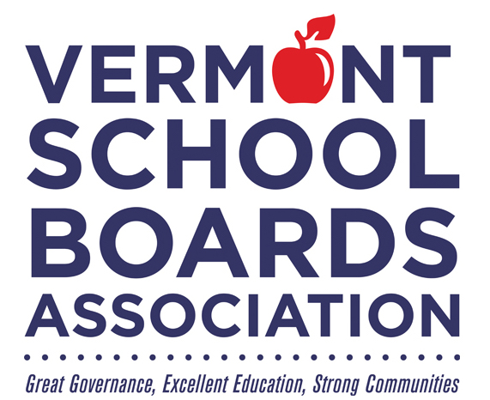

**School Board Recognition Month**

**February 2024**

*Honoring*

**_______________________________________________**

*For commitment to public education and*

*continued service to Vermont's students.*